**Face recognition using CNN:**

**Program:**

from tensorflow.keras.preprocessing.image import ImageDataGenerator

from tensorflow.keras.preprocessing import image

from tensorflow.keras.optimizers import RMSprop

import tensorflow as tf

import matplotlib.pyplot as plt

import cv2

import os

import numpy as np

img = image.load_img("/content/drive/MyDrive/deep learning/archive (1)/basedata/training/face/person_0000.jpg")

plt.imshow(img)

**Output:**

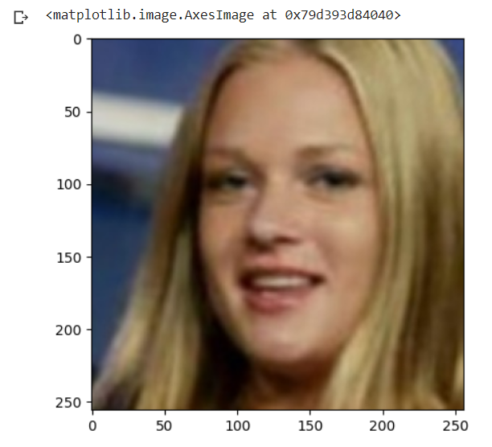

cv2.imread("/content/drive/MyDrive/deep learning/archive (1)/basedata/training/face/person_0000.jpg").shape

**Output:**



train = ImageDataGenerator(rescale = 1/255)

validation =ImageDataGenerator(rescale = 1/255)

trained_dataset = train.flow_from_directory("/content/drive/MyDrive/deep learning/archive (1)/basedata/training",target_size=(200,200),batch_size= 3,

                                                                            class_mode ='binary')

validation_dataset = train.flow_from_directory("/content/drive/MyDrive/deep learning/archive (1)/basedata/validation",target_size=(200,200),batch_size= 3,class_mode ='binary')

**Output:**

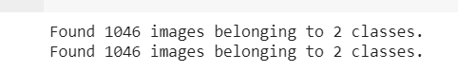

trained_dataset.class_indices

**Output:**



trained_dataset.classes

**Output:**



model = tf.keras.models.Sequential([tf.keras.layers.Conv2D(16,(3,3),activation='relu',input_shape=(200,200,3)),

                                    tf.keras.layers.MaxPool2D(2,2),

                                    tf.keras.layers.Conv2D(32,(3,3),activation='relu',input_shape=(200,200,3)),

                                    tf.keras.layers.MaxPool2D(2,2),

                                    tf.keras.layers.Conv2D(64,(3,3),activation='relu',input_shape=(200,200,3)),

                                    tf.keras.layers.MaxPool2D(2,2),

                                    tf.keras.layers.Flatten(),

                                    tf.keras.layers.Dense(512,activation='relu'),

                                    tf.keras.layers.Dense(1,activation='sigmoid')

                                   ])

model.compile(loss ='binary_crossentropy',

             optimizer = RMSprop(learning_rate=0.001),

             metrics=['accuracy'])

model_fit = model.fit(trained_dataset,

                     steps_per_epoch = 3,

                     epochs =35,

                     validation_data = validation_dataset)

**Output:**

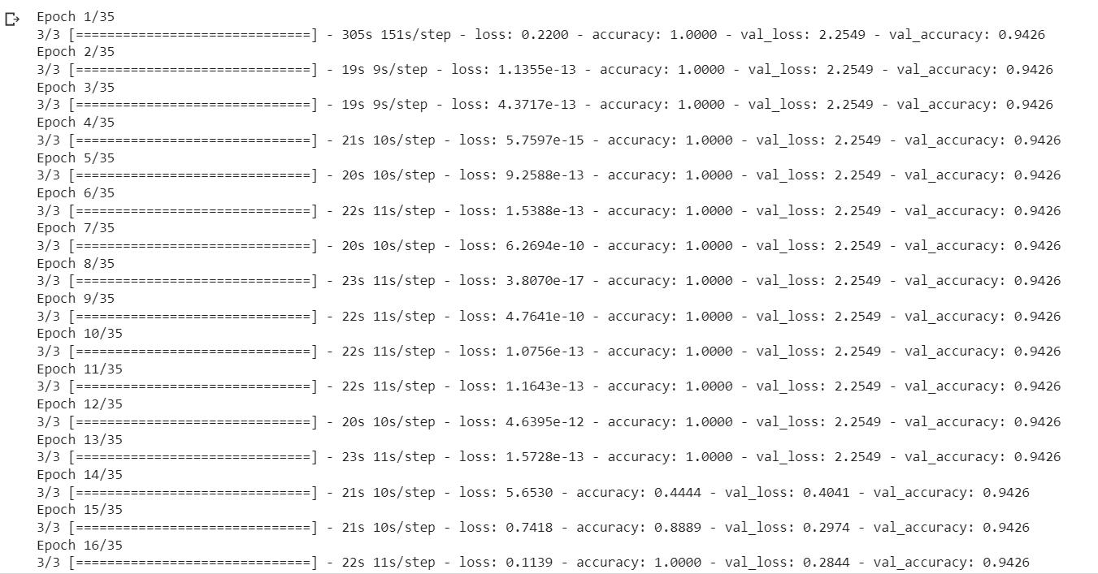

dir_path = "/content/drive/MyDrive/deep learning/testing"

for i in os.listdir(dir_path):

    img = image.load_img(dir_path + '//' + i,target_size=(200,200))

    plt.imshow(img)

    plt.show()

    X= image.img_to_array(img)

    X = np.expand_dims(X,axis=0)

    images = np.vstack([X])

    val = model.predict(images)

    if val == 0:

        print("Face detected")

    else:

        print("Face not detected")

**Output:**

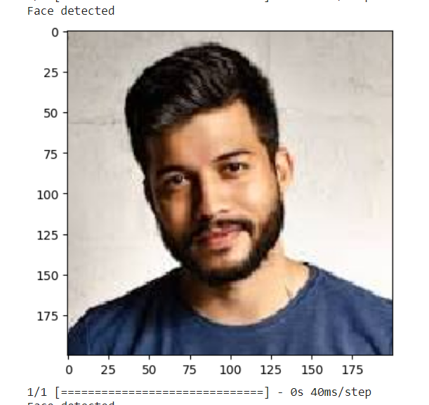

validation_accuracy = model.evaluate(validation_dataset)

print(f"validation accuracy: {validation_accuracy[1] * 100:.2f}%")

**Output:**



import tensorflow.keras.models

model.save('detection_model.h5')

loaded_model = tf.keras.models.load_model('detection_model.h5')

loaded_model